Modify the demo app for the proximity sensor such that you will see the spectrum of colors (at least 5) while the object is getting closer and closer to the phone. For example, if the max range is 1.0, when the distance from phone is 0.9, the background color is brown, when the distance from phone is 0.7, the background color changes to red, when the distance from phone is 0.5, the background color changes to pink, when the distance from phone is 0.3, the background color changes to yellow, and when the distance from phone is 0.1, the background color changes to blue. If the stance from phone is larger than the max range, the background color is set to green as before.

MainActivity.java : The 'MainActivity' class in this Android app interacts with the device's proximity sensor via the 'SensorManager'. It creates a 'TextView' and a 'RelativeLayout' to display sensor data and adjusts the backdrop color based on proximity sensor readings. To optimally manage system resources, the app registers itself as a listener to the proximity sensor in 'onResume' and unregisters itself in 'onPause'. The 'onSensorChanged' method alters the background color of the 'RelativeLayout' and the displayed text in 'proximityValue' based on the data from the proximity sensor, enabling a dynamic visual reaction to sensor changes.

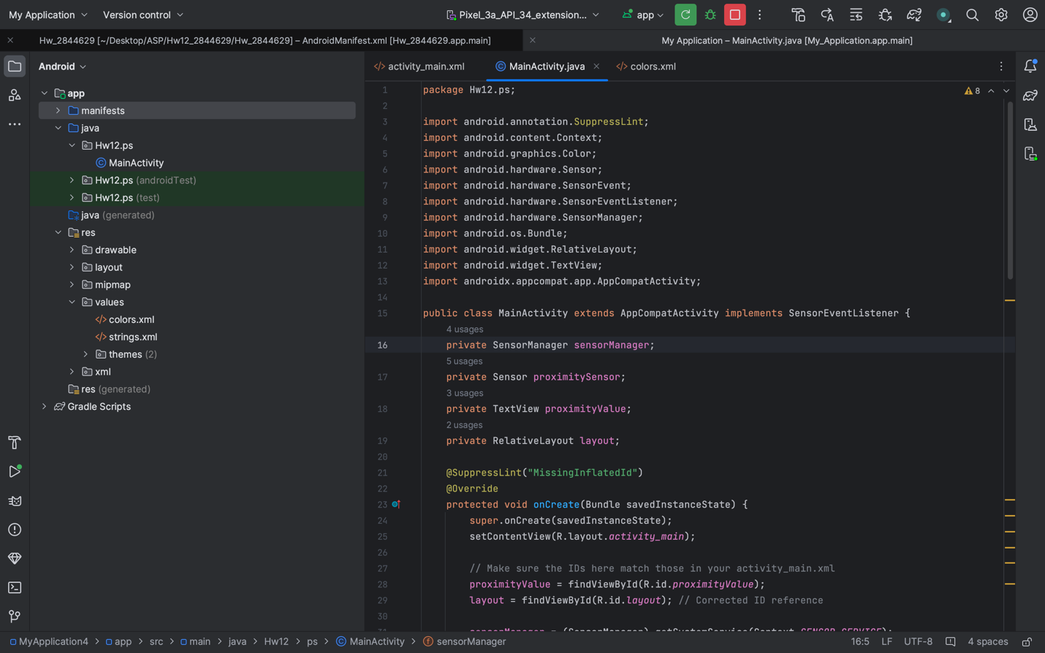

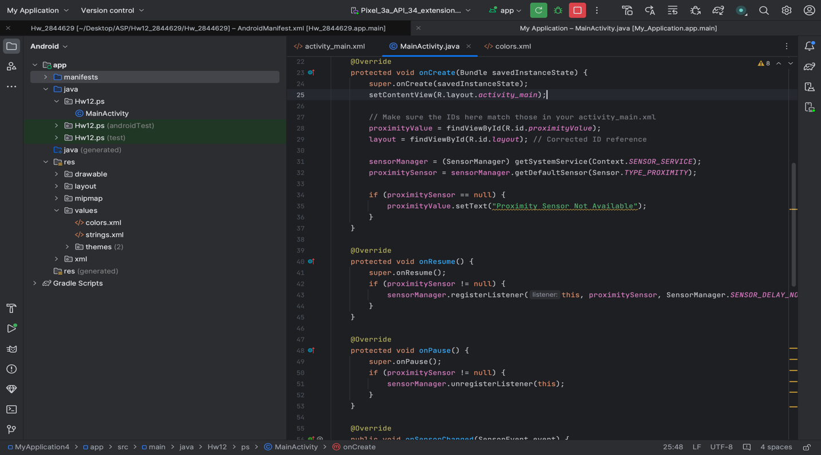

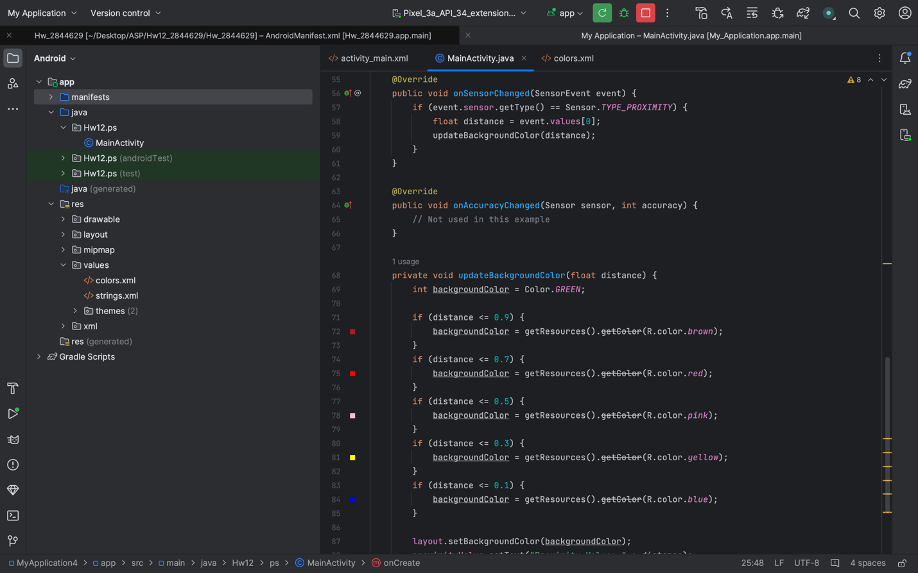

Activity_main.xml : This XML layout for an Android app defines a 'RelativeLayout' as the root container, with a green backdrop, 16dp padding, and a 'TextView' in the center. The 'TextView,' denoted by '@id/proximityValue,' displays the text "Proximity Value: N/A" in white with a font size of 24sp as a placeholder for showing proximity sensor readings.

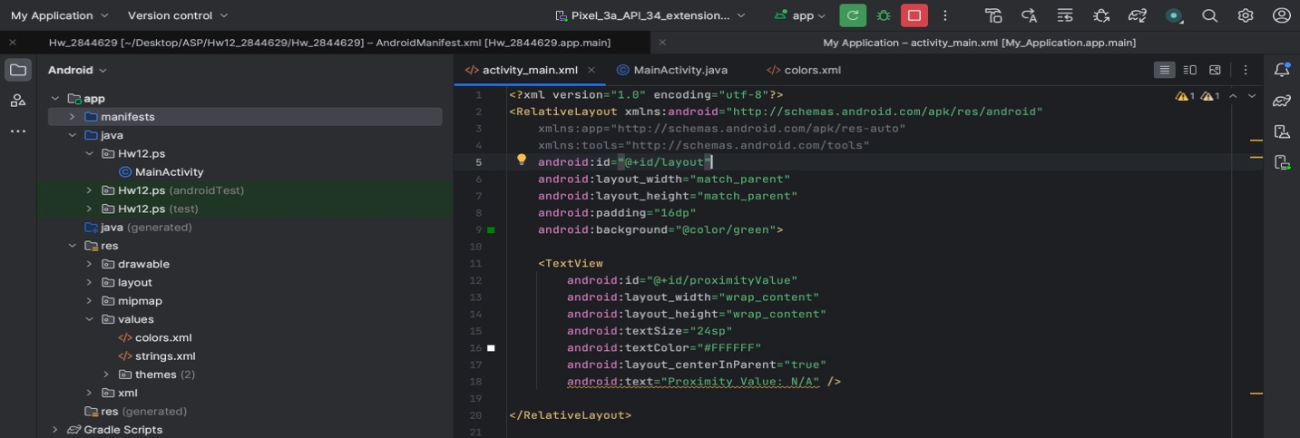

Colors.xml : This XML file, commonly referred to as 'colors.xml,' defines specific color resources for an Android application. Each color is given a distinct name such as "brown," "red," "pink," and so on, as well as a corresponding hexadecimal color value, allowing for consistent and reusable color definitions throughout the app's layout and code.

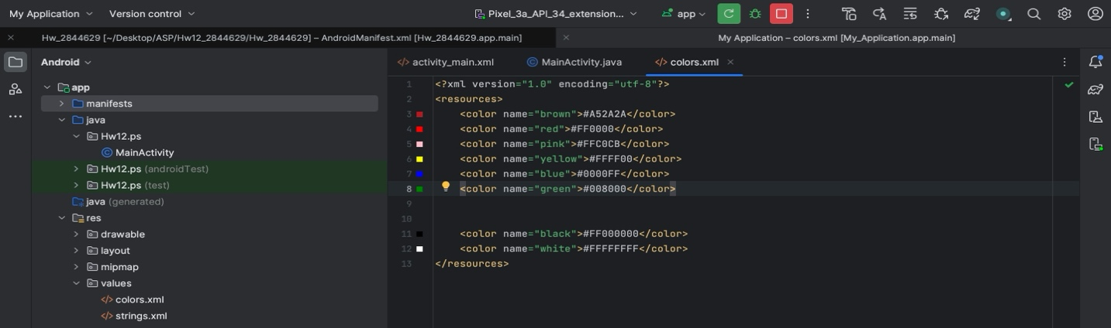

Below are the screenshots of the sensors showing different colors on different distances:

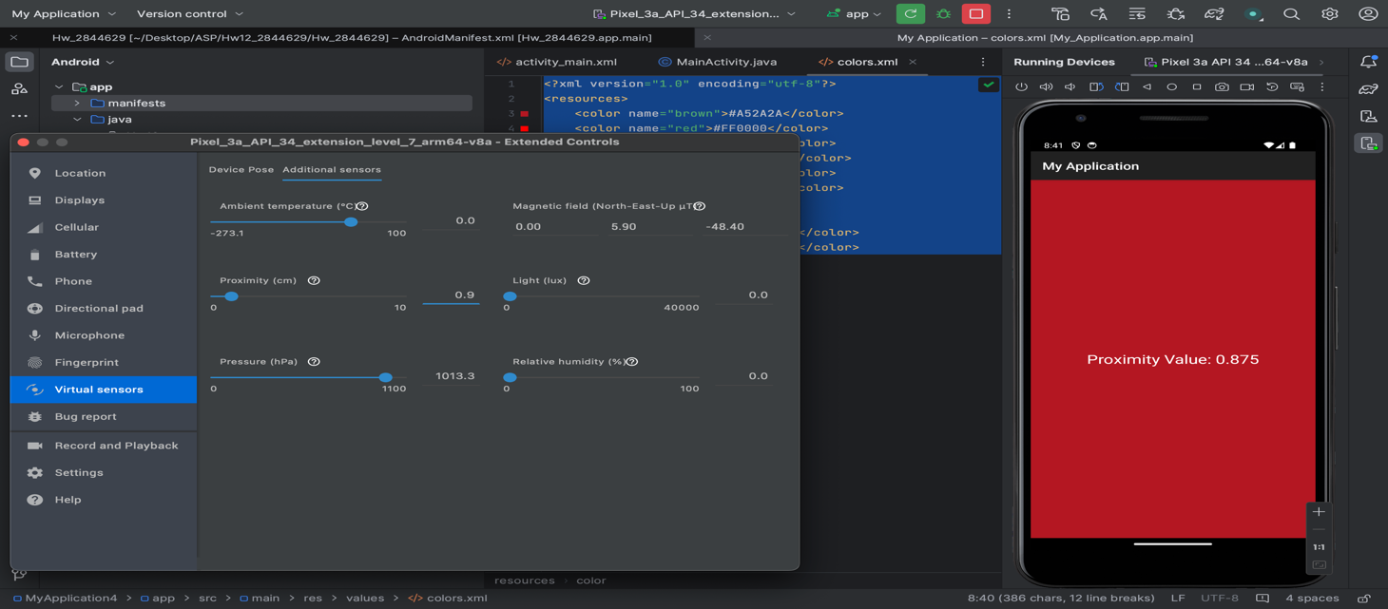

At distance 0.9
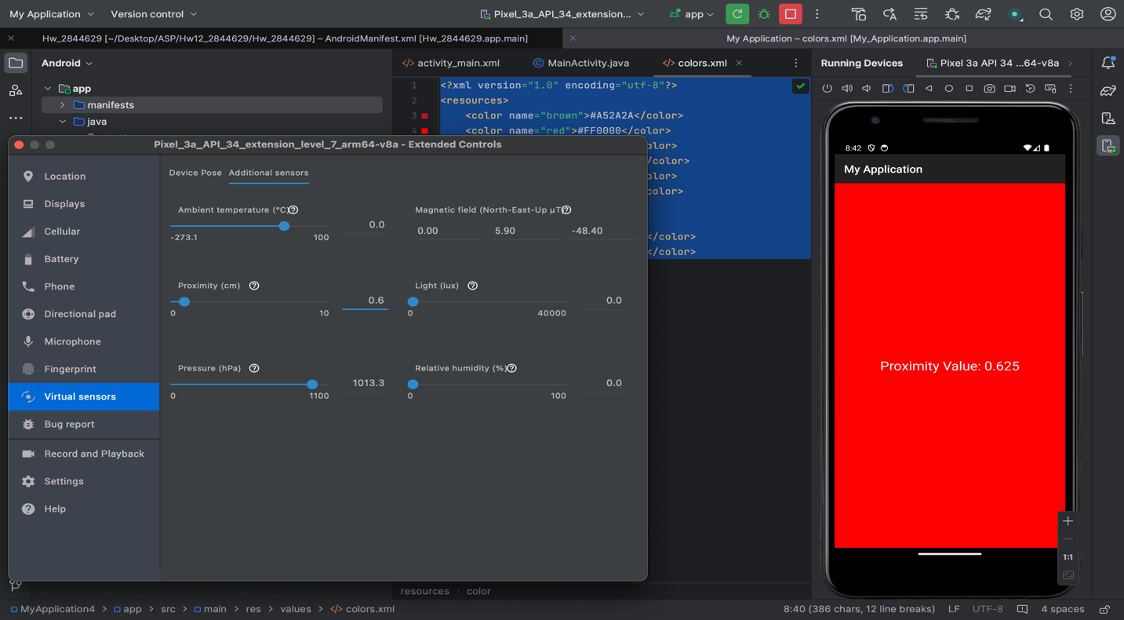

At value 0.6.

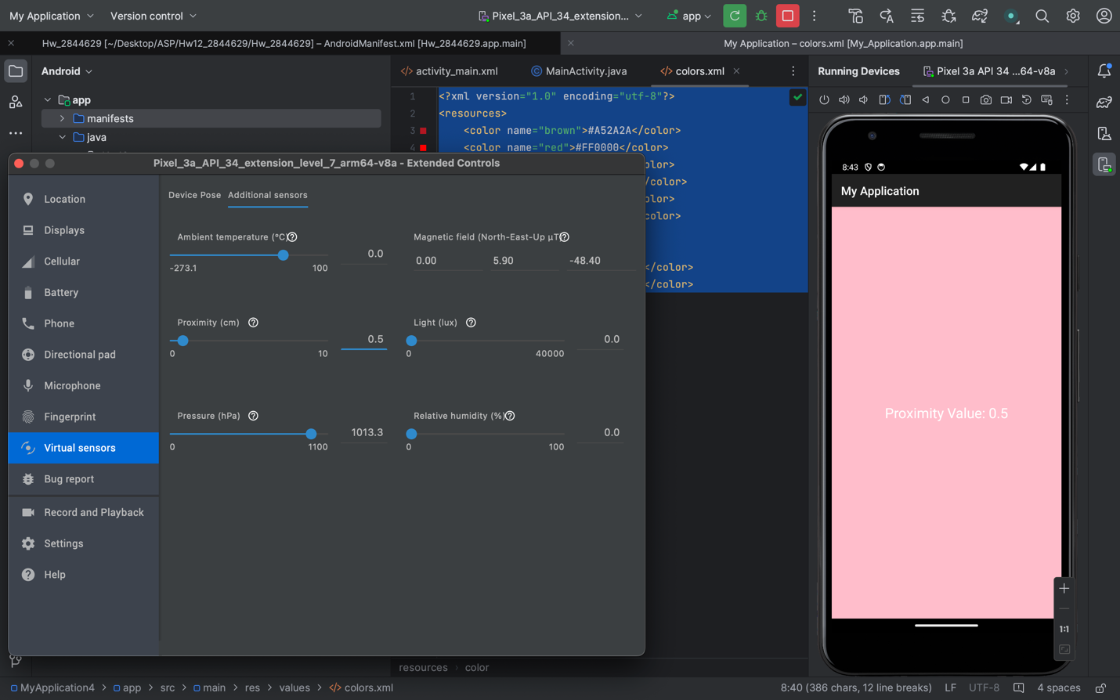

At value 0.5.

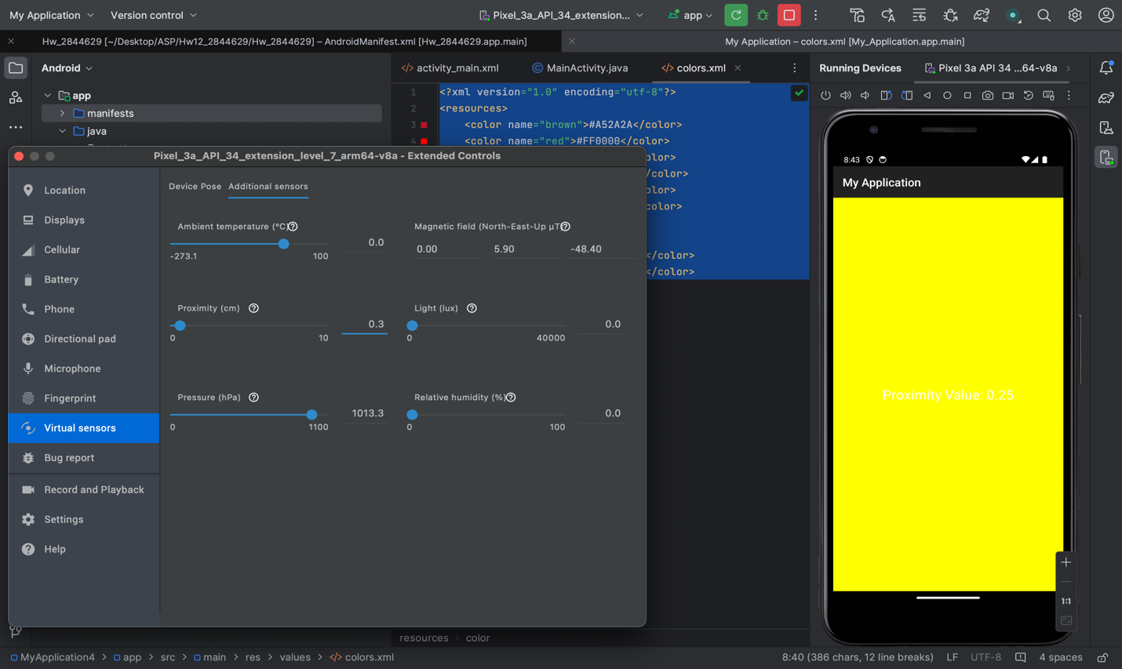

At value 0.3.

